1. Task: Resolve connectivity issues for a given setup.

To document the process of resolving connectivity issues for a given setup, here's a **generalized step-by-step guide**. This can apply to home networks, office setups, or server environments. If you have a specific setup in mind (e.g., Wi-Fi, VPN, LAN, IoT devices), I can tailor the steps further.

**Process: Resolve Connectivity Issues**

**Step 1: Identify the Scope of the Issue**

* **Check if the issue affects:**
  + One device or multiple devices
  + Wired or wireless connections
  + Specific applications or the entire internet

**Step 2: Verify Physical Connections**

* Ensure all cables (Ethernet, power, modem-router) are securely connected.
* Check for damage or wear on cables or ports.

**Step 3: Restart Devices**

* Power cycle the following in order:
  1. Modem
  2. Router
  3. Affected device(s)
* Wait 30–60 seconds between turning devices off and back on.

**Step 4: Check Device Network Settings**

* On the affected device:
  + Ensure Wi-Fi is enabled or the Ethernet cable is plugged in.
  + Check for correct IP address and DNS settings.
  + Disable and re-enable the network adapter.

**Step 5: Run Network Diagnostics**

* Use built-in tools:
  + **Windows:** Troubleshoot problems in Network settings
  + **Mac:** Network Diagnostics
  + **Command line:** ping, tracert/traceroute, ipconfig/ifconfig

**Step 6: Test with Another Device**

* Attempt to connect using a different device:
  + If successful, the issue may be device-specific.
  + If not, the problem may be network-wide.

**Step 7: Check Router/Modem Interface**

* Access the router settings via browser (e.g., 192.168.1.1)
* Look for:
  + Active connections
  + Signal strength (for Wi-Fi)
  + Errors or logs
  + Firmware updates

**Step 8: Bypass or Isolate Components**

* Connect directly to the modem to test internet access.
* Remove network switches or extenders temporarily.

**Step 9: Check ISP Status**

* Visit the ISP’s website or call their support.
* Use a mobile device with cellular data to check for reported outages.

**Step 10: Reset Network Configuration (if needed)**

* **Soft reset:** Reset network settings on the device.
* **Hard reset:** Factory reset the router (last resort).

**Step 11: Document Findings**

* Record:
  + Symptoms
  + Troubleshooting steps taken
  + Resolution or further actions needed

1. Task: Write a report on how to set up and test a basic network

**Report: Setting Up and Testing a Basic Network**

**1. Objective**

**The purpose of this report is to outline the steps required to set up a basic computer network and perform tests to ensure it is functioning correctly. This setup includes connecting devices, configuring IP addresses, and verifying network connectivity.**

**2. Required Equipment**

* **2 or more computers or laptops**
* **Network switch or router**
* **Ethernet cables (Cat5e or Cat6)**
* **Optional: Wireless access point or Wi-Fi-enabled router**
* **A multimeter or cable tester (for cable testing)**

**3. Network Setup Steps**

**Step 1: Physical Connections**

1. **Connect each computer to the network switch or router using Ethernet cables.**
2. **If using a wireless setup, connect computers to the Wi-Fi network broadcast by the router.**

**Step 2: Assign IP Addresses**

**You can assign IP addresses manually or use DHCP (Dynamic Host Configuration Protocol):**

**a. Using DHCP (Automatic)**

* **Ensure the router has DHCP enabled (default setting).**
* **On each computer:**
  + **Go to Network Settings → Change Adapter Options**
  + **Right-click the network adapter → Properties**
  + **Select Internet Protocol Version 4 (TCP/IPv4) → Click Properties**
  + **Select Obtain an IP address automatically**

**b. Static IP Assignment**

* **Use an IP address in the same subnet. Example:**
  + **PC1: IP = 192.168.1.10, Subnet Mask = 255.255.255.0**
  + **PC2: IP = 192.168.1.11, Subnet Mask = 255.255.255.0**
* **Gateway = Router IP (e.g., 192.168.1.1)**

**4. Testing the Network**

**Step 1: Check IP Configuration**

* **On Windows: Open Command Prompt and type:**

**nginx**

**CopyEdit**

**ipconfig**

* **On macOS/Linux:**

**css**

**CopyEdit**

**ifconfig or ip a**

* **Verify that each computer has a valid IP address.**

**Step 2: Ping Test**

* **To test connection between two computers:**
  + **On PC1, open Command Prompt and type:**

**nginx**

**CopyEdit**

**ping 192.168.1.11**

* + **A successful ping shows response times (e.g., “Reply from 192.168.1.11: bytes=32 time=10ms”)**

**Step 3: Test Internet Connection (If Connected to Router with Internet)**

* **Open a web browser and visit any website.**
* **Alternatively, in Command Prompt:**

**nginx**

**CopyEdit**

**ping google.com**

**Step 4: Share Files or Folders (Optional)**

* **Enable file sharing in network settings.**
* **Share a folder and access it from another computer using:**

**CopyEdit**

**\\ComputerName\SharedFolder**

**5. Troubleshooting Tips**

| **Problem** | **Possible Cause** | **Solution** |
| --- | --- | --- |
| **No IP address** | **DHCP is off** | **Set static IP or enable DHCP** |
| **Ping fails** | **Firewall or cable issue** | **Disable firewall temporarily; test cable** |
| **No internet** | **Wrong gateway or DNS** | **Check router settings and DNS servers** |

**6. Conclusion**

**Setting up a basic network involves physically connecting devices, assigning IP addresses, and verifying communication using simple tests like ping and IP configuration. With this setup, devices can share resources and access the internet if a router is connected.**

1. Test: components using a multimeter.

Testing components with a multimeter is a crucial skill in electronics. Here’s a quick guide on how to test common components using a digital multimeter:

**1. Resistors**

**Test:** Resistance  
**Multimeter Setting:** Ω (Ohms)

* Disconnect one leg of the resistor from the circuit.
* Touch probes to each end of the resistor.
* Read the value and compare it to the color code or datasheet.
* A high or infinite reading may indicate a damaged resistor.

**2. Capacitors**

**Test:** Capacitance or Continuity (for basic check)  
**Multimeter Setting:** Capacitance (symbol: ‖) or Diode/Continuity

* Discharge the capacitor before testing.
* Connect probes; the multimeter should show capacitance in µF or nF.
* If using continuity/diode mode: the meter will briefly show charging (rising resistance), then OL (open) for a good capacitor. If it shows 0 or continuity, it's shorted.

**3. Diodes (including LEDs)**

**Test:** Forward voltage drop  
**Multimeter Setting:** Diode mode (🔺|→|)

* Connect the red probe to the anode (+) and the black to the cathode (–).
* A good silicon diode typically shows 0.6–0.7V.
* OL or no reading in both directions indicates it's open; 0V or very low both ways means it's shorted.

**4. Transistors (BJT)**

**Test:** Diode test mode  
**Multimeter Setting:** Diode mode

* Identify the base, collector, and emitter.
* NPN: Base to emitter and base to collector should each show ~0.6–0.7V.
* PNP: Reverse polarity.
* No continuity or low resistance both ways = faulty transistor.

**5. Fuses**

**Test:** Continuity  
**Multimeter Setting:** Continuity (sound wave symbol)

* Touch both ends of the fuse.
* A beep or near-zero resistance = good fuse.
* No sound or OL = blown fuse.

**6. Inductors/Coils**

**Test:** Resistance (basic check)  
**Multimeter Setting:** Ω

* Measure resistance across the coil.
* Should show low resistance (a few ohms).
* OL or very high resistance = broken winding.

**7. Switches**

**Test:** Continuity  
**Multimeter Setting:** Continuity

* Connect probes to switch terminals.
* Toggle the switch; it should go from OL (open) to 0 (closed) depending on its positi

1. Task: Create a checklist for diagnosing hardware issues.

If you're looking for something specific or a little more powerful, you'll need to turn to third-party software.

There are [many Windows diagnostic tools](http://www.makeuseof.com/tag/13-windows-diagnostics-tools-check-pcs-health/), but you can diagnose most Windows issues **with these X apps**.

**1. MemTest86+**

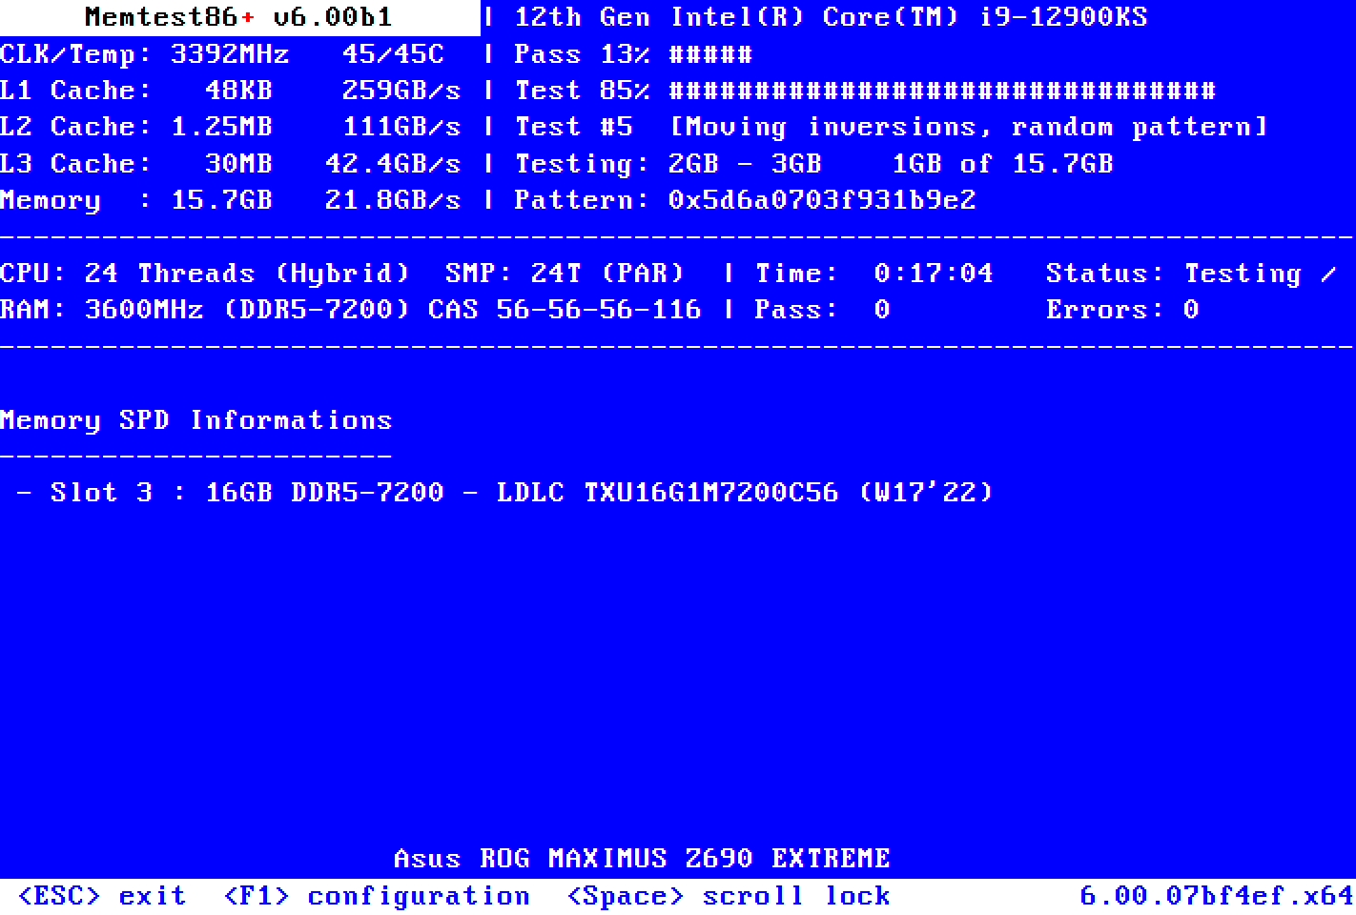[**Memtest**](https://www.memtest.org/)

[**MemTest86+**](https://memtest.org/) is well-established as the best tool to test your RAM on Windows. It's more powerful than Microsoft's Windows Memory Diagnostic tool and is free and open source. Furthermore, unlike the Windows tool, MemTest86+ also has a full-featured graphical interface.

Memtest86+ uses two RAM testing algorithms and supports DDR5, DDR4, DDR3, and DDR2 RAM. You boot it directly from a USB flash drive or a CD, and Microsoft has signed the app's code for Secure Boot compatibility.

**Check Your Computer's Battery Health**

Another piece of laptop hardware that's prone to failure is the battery.

We've written about several tools that'll help you [test the health of your laptop battery](https://www.makeuseof.com/tag/5-tools-analyze-laptop-battery-life/), but the best option for Windows users is the built-in tool, **powercfg**. The powerful command generates a precise report on your battery status and history, showing you its capacity and more.

1. Open the Start Menu, input **CMD**, right-click the Best Match, and select **Run as Adminstrator.**
   * Alternatively, Windows 11 users can press **Win + X** to open the Power Menu and select **Terminal (Admin)**.
2. Now, input **powercfg /batteryreport** and press Enter. It saves a battery report in HTML format to **C:\Windows\system32\battery-report.html.**
3. Browse to the file location and open it. The battery report will open in your browser.
4. format to **C:\Windows\system32\battery-report.html.**
5. Browse to the file location and open it. The battery report will open in your browser.

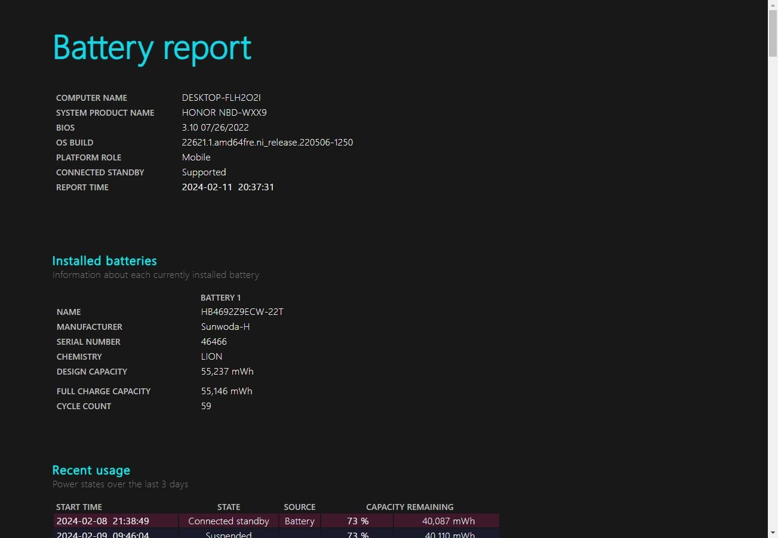

The first part of the battery report details your hardware, current battery status, total capacity, and current capacity, which is all great information. If you scroll down, you'll find more information on charging status, periods, and more.

**Diagnose Windows Hardware With PartedMagic or The Ultimate Boot CD**

Another way to diagnose faulty hardware on a Windows system is with a Linux Live CD or USB. There are [several rescue and recovery disks for Windows](https://www.makeuseof.com/tag/5-best-rescue-disks-windows-system-restore/), but two useful distros for diagnosing faulty Windows hardware are [PartedMagic](https://partedmagic.com/" \t "_blank) and the [Ultimate Boot CD](https://www.ultimatebootcd.com/).

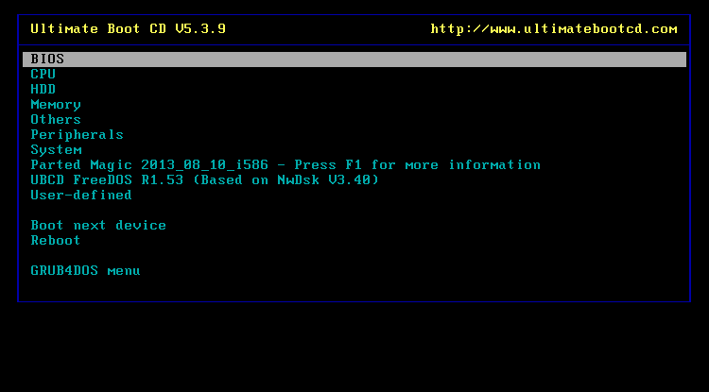[Ultimate Boot CD](https://www.ultimatebootcd.com/)

PartedMagic is a paid tool but features several useful tools for benchmarking and checking your hardware, not to mention its disk partitioning, closing, rescue, and erasing tools, whereas the Ultimate Boot CD is completely free and also features numerous Windows hardware checking tools, testing and analytics options, plus fixes for common issues. As of Ultimate Boot CD version 5, the rescue disk also includes a version of PartedMagic (for partitioning and managing hard drives), so it's a very handy tool to keep around.

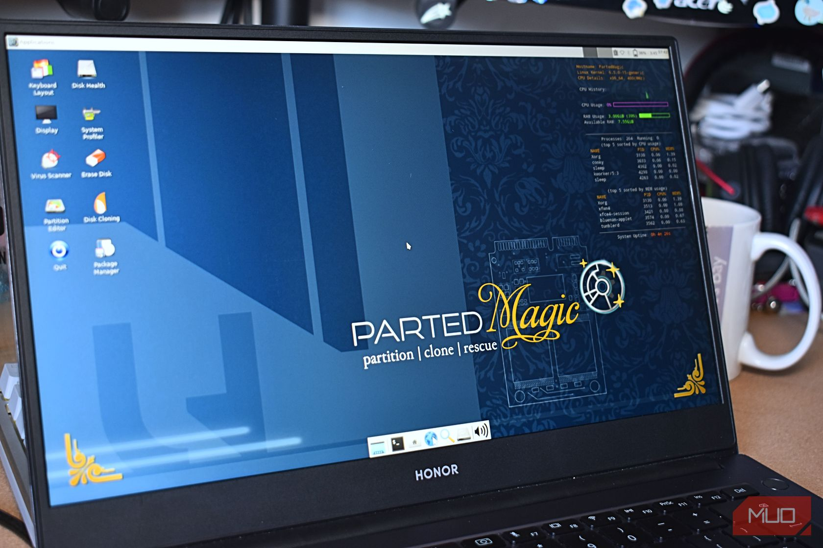Gavin Phillips/MakeUseOf

To use PartedMagic or the Ultimate Boot CD, you'll need [an ISO to bootable USB tool](https://www.makeuseof.com/tag/10-tools-make-bootable-usb-iso-file/). I would suggest Rufus, as it's super simple to use and takes care of your ISO and USB flash drive configuration.

1. First, download[PartedMagic](https://partedmagic.com/store/" \t "_blank); it requires a 15 dollar single fee. Alternatively, download [Ultimate Boot CD](https://www.ultimatebootcd.com/download.html), which is free.
2. Use an ISO-to-bootable USB tool like [Rufus](https://rufus.ie/en/) to burn the PartedMagic ISO or Ultimate Boot CD to a USB flash drive.
3. Turn off the computer you want to diagnose. Insert the PartedMagic or Ultimate Boot CD USB flash drive (or CD).
4. Now, you'll need to [change the boot order](https://www.makeuseof.com/tag/how-to-change-the-boot-order-on-your-pc-so-you-can-boot-from-usb/) to select the PartedMagic or Ultimate Boot CD drive. Most Windows machines can change boot order by pressing ESC or F8 during the boot process, but your machine may have a specific key. However, if [Windows fast startup is enabled](https://www.makeuseof.com/what-is-windows-fast-startup-why-disable-it/), you may need to switch this off to make the process work.
5. Once booted, you can begin troubleshooting and benchmarking Windows using PartedMagic or Ultimate Boot CD.

regular operating system, so it's not a confusing interface.

Keeping an eye on your hardware and running PC hardware tests are only two parts of maintaining a smooth, healthy computer. One of the most important ways to keep your computer healthy is to clean it! Dust and other types of build-up in your fans and case are a sure-fire PC-killer. Take the time to pop the side panel off your PC case and clean out the dust every few months—your computer and wallet will thank you.